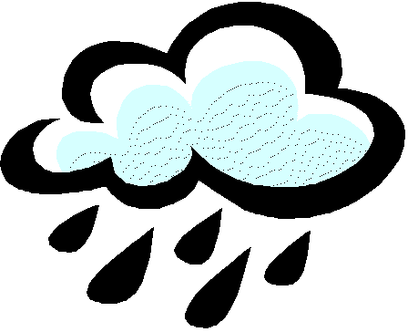

Bangor Area Storm Water Group Meeting

August 14, 2014; 9:00 am – 11:30 am

Followed by brief Executive Committee Meeting

Location: Orono Town Hall, Orono, Maine

DRAFT AGENDA

9:00 am Welcome and Introductions

9:10 am Review of Work Priorities from Last Meeting and Draft BASWG Calendar

9:20 am Update on Ch. 500 and Proposed CWA Rule

9:30 am Introduction of the Maine Snow and Ice Control Environmental BMP Manual
Brenda Zollitsch and Mike Gladu
- Overview of project goals and process to date
- How manual is planned to be used
- Connection to BASWG 4th Outreach Plan
- Presentation of the manual components
- Next steps – publication, access, trainings, roundtable and Volume 2.0
10:00 am Looking into the Future: The Potential for Road Weather Information Systems
Presentation by AMEC about emerging technologies for winter snow and ice control

10:15 am Coffee Break

10:30 am MS4 Sharing about New Developments, Technologies, and Programs
A monthly opportunity for MS4s to share ideas, successes, lessons learned & questions

10:50 am Education and Outreach Update/Planning
- Website and social media work
- 4th Outreach Plan: Chlorides
- Events calendar
11:15 am Organizational Business
- Approval of July BASWG meeting minutes (Bob O.)
- Financial transfer, budget update and MS4 Invoices (Patrick D. and Bob O.)
- Agenda plans for next meetings
11:30 am BASWG Monthly Meeting Adjourns

