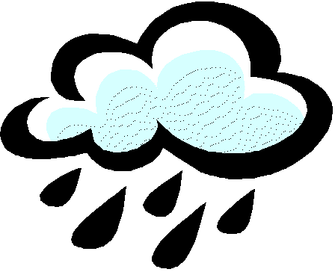

Bangor Area Storm Water Group Meeting

October 8, 2015

Location: 2nd Floor Council Chambers, Orono Town Office, Orono, Maine

12:30 pm – 3:30 pm

AGENDA

12:30 pm BASWG Business Meeting and Brown Bag Lunch
- Organizational Business
  - DEP receipt of BASWG PY2 Regional Report Confirmed
  - Roundtable Summary and Budget Update
  - Administration of new E&O Contract
  - Need for E&O Chair (BASWG member)
- Updates:
  - MEWEA Stormwater Committee Update
  - Maine Stormwater Conference (November 16-17)
  - EPA Urban Waters Grants Program (Webinar on 10/22; Due 11/20)
  - Tribal Waters/CWA Program Delegation
  - DEP Issue Profile, Enforcement Matrix and Chapter 500 follow-up

1:00 pm Education and Outreach Special Meeting: Planning with New Consultant Team

Pulse Marketing & Stillwater Environmental Engineering

Introductions and Project Background
- What has been done so far; what has worked and what hasn’t
Goal Setting
- Identification of goals for next nine months
- How will we measure success?
Identification of Target Groups

Listing of Resources and Assets Available for Use

Specific Tasks
- Upcoming events
- Editorial calendar for social media
- Website updates
- Public relations
- Survey to Quantify Behavior Change (Part 1)
3:30 pm BASWG Meeting Adjourns

